ECOFARMS Panama
PROJECT OVERVIEW

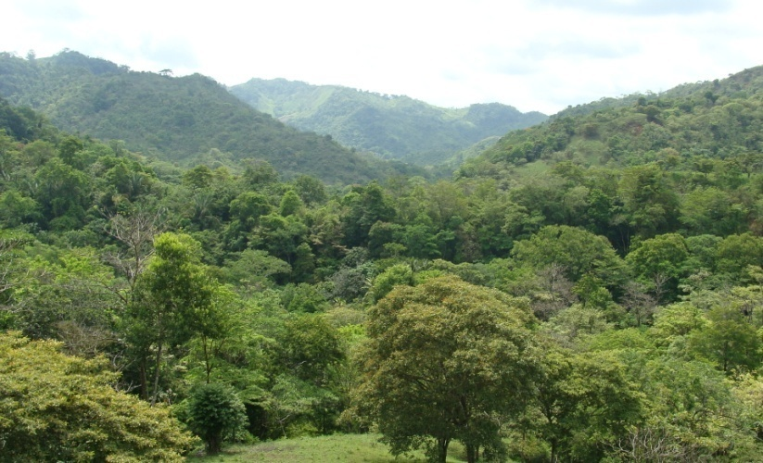
ECOFARMS Panama is a nonprofit organization aimed at conserving and restoring tropical rainforest in the area of the Mamoni River, through the development and application of sustainable land use systems. The project model includes the conservation of tropical rainforest to protect their environmental services, as for example the protection of biodiversity, soil quality, water balance as well as the storage of carbon; while at the same time, restoring degraded land, formerly used in cattle farming and subsistence agriculture, through sustainable reforestation. These activities will help conserve the existing rainforest and extend the conservation area.
The activities previously mentioned, will be supported by the selling of ECO-tourism services and the production and selling of organic eco-friendly products to the local and international market.
VISION
ECOFARMS Panamas vision is to be a pioneer in the development of new land use systems that will allow the sustainable management and conservation of tropical rainforest in the Mamoni river area.
ECOFARMS Panama BACKGROUND
Starting in 1992, the Panamanian couple Fernando Lopez Alba and Dalis Rodrigues de Lopez, both co-founders of ECOFARMS Panama, decided to buy some land in the area of the Mamoni River, Panama, where they can spend their weekends and holidays. Since its beginning, Finca Hermanos Lopez, ECOFARMS Panama project site, decided to conserve a small strip of land of about 12 hectares. In 2010, El Roble Reserve was born, and is one of the biggest reserves in the area of Gaspar Sabanas, totaling 300 hectares of pure forest. In 2010, their youngest son decided to take over the administration of the farm and in 2011, ECOFARMS Panama was born. Today, ECOFARMS Panama wishes to conserve more tropical rainforest and restore the existing land that was destroyed by inadequate land use systems.
Our Team
Fernando J. Lopez- BSc Business Administration, Towson University Founder and Director
Fernando Lopez Alba Graduate in law, University of Panama Co-founder and legal department.
Dalis R. de Lopez BSc in Biology, Graduate in law, University of Panama Co-founder, legal department and in-site biologist
Fernando de J. Lopez Rodriguez BSc Mechanical Engineering-Technical University of Panama, MSc Mechanical Engineering- University of Santa Catarina, Brasil. Green building and renewable energy expert.
Carola Paul Dipl. ing. silv. (Univ.), MSc in Forest Science. Reforestation Program, tropical restoration and tropical conservation.
Daniel Serrano Business systems, telecommunications, and related technology infrastructure

Current Projects
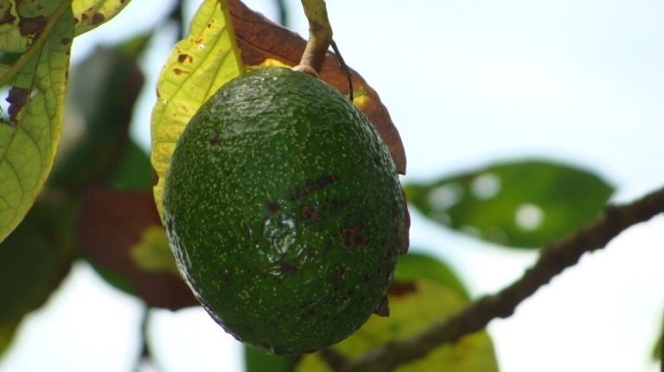
Past and Current Projects
1992-present: Conservation of rainforest around the Mamoni River region. Creation of small conservation areas, and cattle growing with the use of silvi-pasture systems.

2010: Study and Development of SLUC (Sustainable Land Use Concept). Through the use of this land use system, ECOFARMS Panama seeks to reduce and eliminate the use of agrochemicals on site and increase their conservation area.

2010-Present:
- 90 % reduction in the use of agrochemicals.
- Organic production.
Short Term Projects
Year 2011
- Building of “El Tamarindo Lodge”: Will host project offices, tourism rooms and meeting places.
- Establishment of organic production plots.
- Design and installation of the first photovoltaic energy production system, which will provide energy for all project facilities.
- Research in new sustainable reforestation methods and tropical soil restoration.
- Create a database of animals and plant species, in order to assess the biologic impact of the application of new land use systems.

Year 2012
- Building of tropical Eco-lodges: Design and building of tropical ecologic lodges.
- Rainforest Music Sessions: Aimed at increasing awareness about the damage caused by inadequate land use systems and deforestation.
- Donate a tree plan: Aimed at raising funds to study, and establish the first reforestation plots.
- Adopt a parcel: Conservation through the donation of rainforest plots.
- Tree house- wild animal watching site: Design and building of a study station located in El Roble Reserve, intended to the study of wild animals in the area.

Long term Projects
- Acquisition of rainforest, and pasture land for reforestation.
- Education session on tropical conservation.
- Carbon Storage Plan.
- Educational Tourism.

Lead Partners
Finca Hermanos Lopez
Technical University of Munich
Grupo Musical Vozes da America.

ECOFARMS PANAMA – Georg-August-Universität Göttingen
University staff and students are welcome to be involved at any time.
Areas of development:
-Organic food production: Students are welcome to study and experience organic and sustainable production methods, through our in-site farm.
-Forest Management: Research and development of our first reforestation efforts aimed at restoring and conserving tropical rainforest in Panama.
-Sustainable Tropical Design: Students are welcome to be involved in the design and building of infrastructure in the project.
-Animals and Plant census: Create a database of flora and fauna, in order to assess the biologic impact of activities on the project.
-Management: We welcome student who wish to be involved in the management of ECOFARMS Panama, designing marketing strategies, market research for products and services, web-management, and sustainable business management.

