Dedication to Dick Brummitt

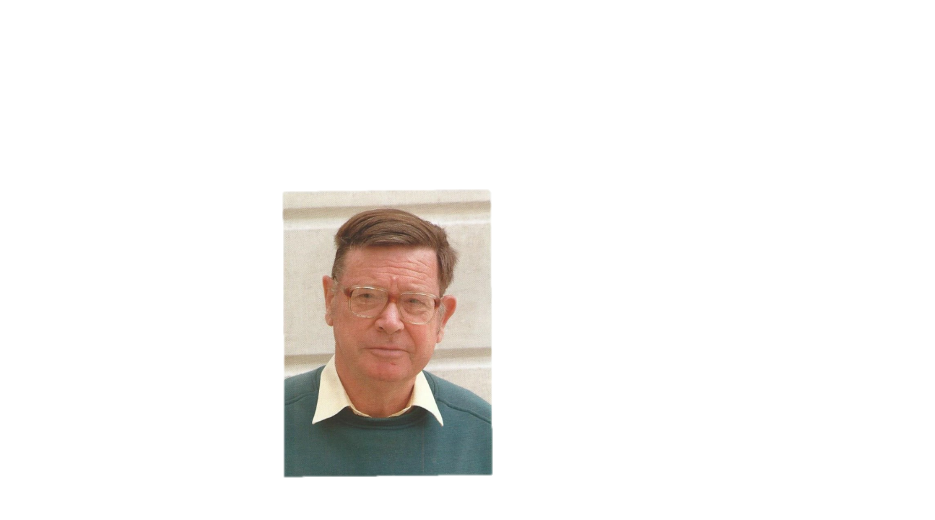
Richard Kenneth Brummitt
1937 – 2013

It is with sad hearts that we dedicate a forthcoming series of papers on paraphyly in the Annals of Missouri Botanical Garden to our friend and colleague Dick Brummitt (U.K.). Due to declining health, he was unable to travel to Melbourne for presentation of his talk at the IBC symposium in 2011, but he did prepare a video of his lecture that was shown during his time slot on the program (still available online at: http://www.uni-goettingen.de/downloads/Dick_Brummitt_Conference_video.mp4 ). Although this video format did not allow questions, it nonetheless was effective in stimulating discussion from the audience. Dick was a person who could be passionate regarding particular ideas, and the necessity of paraphyly in biological classification was one of these. His feelings came through clearly and forcefully in his oral presentation. We are proud and honored to have his paper included here in this symposium series. We wish he were still with us to continue the discussions.
Tod Stuessy* & Elvira Hörandl

*Herbarium, Museum of Biological Diversity, The Ohio State University, 1315 Kinnear Road, Columbus, Ohio 43212, U.S.A., e-mail: stuessy.1@osu.edu

