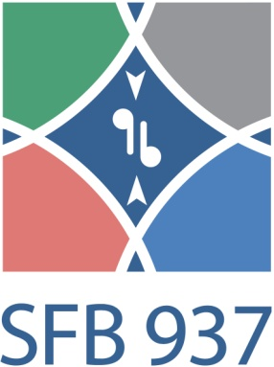
List of guests
Winter semester 2015/16

27/10/2015 | Prof. Dr. Stefan Klumpp | Georg-August-University Göttingen | Magnetism and motility of magnetotactic bacteria
10/11/2015 | Autumn School | Hohegeiß, Harz | Diverse
24/11/2015 | Prof. E. Schäffer | Universitiy of Tübingen | Molecular Machines under Tension: How Kinesins Get to the Microtubule End & DNA Recombination
15/12/2015 | Dr. F. S. Wouters | University Medical Center Göttingen
12/01/2016 | Dr. K. Franze | University of Cambrigde | CNS mechanics: forcing neuronal development and regeneration
26/01/2016 | Prof. P. Kohl | Imperial College London | Systems Biology of the Heart: Model or Muddle
09/02/2016 | Dr. A. Ros | Arizona State University | Microfluidics for Serial Femtosecond Crystallography

