Organization
The Symposium cum Workshop is organized by the University of Tehran, Faculty of Entrepreneurship and the University of Göِttingen, CeTSAF, Germany with the financial support of the German Academic Exchange Service (DAAD).

Participants
The participants are graduates from German Universities, preferably the University of Göِttingen (Alumni), Kassel and Marburg coming from Iran and are involved in academic teaching and research in the corresponding fields of Higher Education Management and related disciplines.
Furthermore, the organizers of the symposium wholeheartedly welcome the presence of other practitioners and university professors who are expert in this subject.

Venue
The Symposium and Workshop will take place at the University of Tehran, Faculty of Entrepreneurship.

Date
August, 24 to 27, 2008

Abstracts
Abstracts to one of the above mentioned topics, not exceeding 500 words should be sent to: gian@ent.ut.ac.ir not later than July, 15, 2008.
In case of large number of applications, a group of peer reviews decide on the base of quality and relevance of the abstracts on participation of the applicants.
Invited participants will be requested to hand over their extended abstracts and full papers as well as posters till August, 15, 2008.

Program
The final program will be sent to participants soon after the abstracts reach the organizers.

Language
The language of the meeting is English

Contact persons
In Germany:
Dr. Siawuch Amini, Institute of Socio-Cultural and Socio-Economic Studies (ISOS), University of Kassel, Steinstrasse 19, 37213, Witzenhausen, Germany, Tel: +49(+) 5542 507586,
E-mail: sia.amini@t-online.de
In Iran:
Dr. Saeed Jafari Moghaddam & Dr. Mostafa Razavi, the Faculty of Entrepreneurship, the University of Tehran, Iran, Tel: + 98 (+) 21- 8833 9094-8
E-mail: gian@ent.ut.ac.ir

GIAN Office in Tehran:
Dr. Mostafa Razavi, the University of Tehran, Iran, Tel: + 98(+) 21- 8833 9094-8,
E-mail: gian@ut.ac.ir
On the Occasion of the Year of Innovation and Flourishment

The 5th Symposium
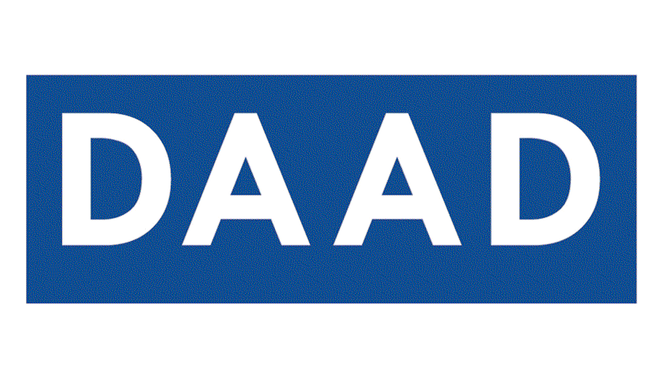
Announcement
and Call for Papers

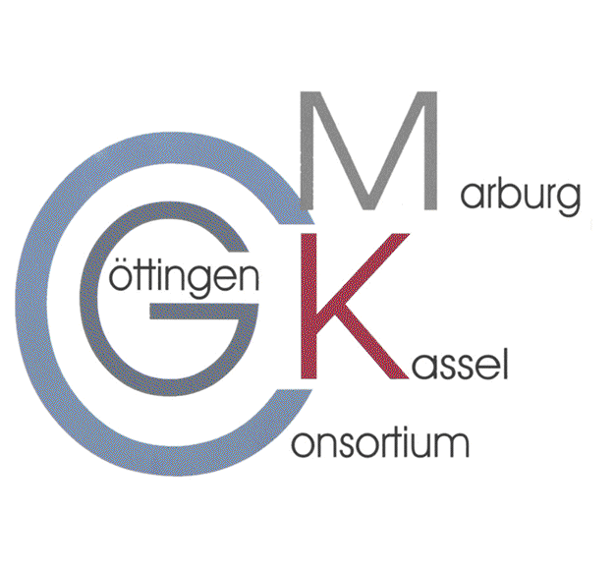
Knowledge

Management
and
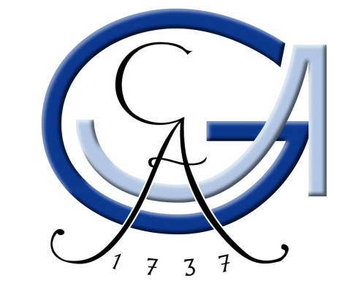
Innovation
In
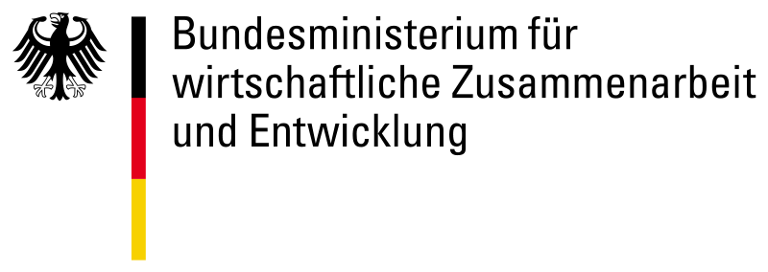
Higher
Education

GIAN
Germany Iran Alumni Network

Faculty of Entrepreneurship
University of Tehran,

Georg-August-Universität
Göِttingen, Germany

24th - 27th August, 2008

