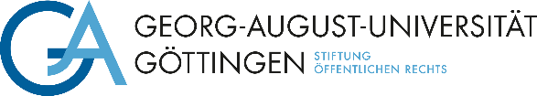

The Department at the Georg-August-Universität Göttingen is looking to fill the position of

**Research Assistant (f/m/d)**

This position should be filled by Date. The regular working hours will be (currently       hours per week) with a limited contract of       year(s) / to      . Salary: **Pay grade 13 TV-L.**

The position's duties include in addition to JOB DESCRIPTION,

teaching courses as defined in Section 31 of the Higher Education Act of Lower Saxony(NHG), administering examinations and working on research in the area of RESEARCH AREA.

The successful candidate will hold a highly qualified PhD in SUBJECT and have focused on research in SUBJECT. The applicant's willingness to work on setting up a research network on SUBJECT (including proficiency in the LANGUAGE language) is equally as desirable as is teaching experience and publishing results. This post is designed to foster young researchers and scientists and give the successful applicant the opportunity to pursue a post-doctoral degree. Under special circumstances, the position is suitable for half-time.

The University of Göttingen is an equal opportunities employer and places particular emphasis on fostering career opportunities for women. Qualified women are therefore strongly encouraged to apply in fields in which they are underrepresented. The university has committed itself to being a family-friendly institution and supports their employees in balancing work and family life.The mission of the University is to employ a greater number of severely disabled persons. Applications from severely disabled persons with equivalent qualifications will be given preference.

Please send your application with the usual documents (also in electronic form) by Dateto **Georg-August-Universität Göttingen**, **Department,****StreetHouseNr,** **PLZ Göttingen,**



**e-mail:** **.**

If you have any questions, please contact Ms./Mr.

phone:      , e-mail:      .

**Please note:**

With submission of your application, you accept the processing of your applicant data in terms of data-protection law. Further information on the legal basis and data usage is provided in the Hinweisblatt zur Datenschutzgrundverordnung (DSGVO) <https://www.uni-goettingen.de/hinweisdsgvo>