Title Goes Here

Seminar / Bachelor / Master Thesis

Submitted to

Chair of Interorganizational Information Systems
Prof. Dr. Manuel Trenz
University of Göttingen

In
Month Year

By
Firstname Lastname

Student ID:
1000000

Academic Program:
B.Sc. Business Information Systems

Academic Advisor
Max Mustermann

Abstract
Here goes your abstract. This is exemplary text in “Text” style. A typical abstract has 150-250 words. This template should serve as a template for students, supporting them in writing theses at the Chair of Interorganizational Information Systems. The language of the theses is English (decide on US or GB spelling and use it consistently!). Also, refer to the kick-off slides for more notes on writing. For submission requirements, refer to A 2. Please note that all text, figures, tables, appendices and references are placeholders!
Table of Contents

1 This is a Heading 1 Paragraph 1
2 This is Another Heading 1 Paragraph 1
2.1 This is a Heading 2 Paragraph 1
2.1.1 This is a Heading 3 Paragraph 1
2.1.2 This is Another Heading 3 Paragraph 1
2.2 Figure Style 1
2.3 Another Figure 1
2.4 Table Style 2
2.5 Another Table 3
2.6 References in Text 4
2.6.1 Indirect Citation in Text 4
2.6.2 Direct Citation in Text 4
2.6.3 Modified Direct Citation in Text 4
2.7 Managing References 4
2.8 List of References 5
References 6
Abbreviations v
Appendix vi

List of Figures

Figure 1. Information Systems Success Model (adopted from: DeLone and McLean 1992) 1
Figure 2. Mediation Results 2

List of Tables

Table 1. Types of Theories (based on: Markus and Robey 1988) 2
Table 2. Initial Factor Loadings 3
Table 3. Zotero Links 5

- This is a Heading 1 Paragraph
Here goes your text. This is exemplary text in “Text” style. Note that the nouns and verbs in the headings and captions are in capital letters (“englische Titelgroßschreibung”).
- This is Another Heading 1 Paragraph
  - This is a Heading 2 Paragraph
Here goes your text. This is exemplary text in “Text” style.
    - This is a Heading 3 Paragraph
Here goes your text. This is exemplary text in “Text” style.
    - This is Another Heading 3 Paragraph
Here goes your text. This is exemplary text in “Text” style. Note that there is no blank page before the new chapter.
  - Figure Style
This is exemplary text with cross reference (see Figure 1) to show correct figure style. The caption is in “Figure/Table Caption” style and integrated, but below the figure.
System Quality
Information
Quality
Individual
Impact
Organizational Impact

Use
User Satisfaction

Figure 1. Information Systems Success Model (adopted from: DeLone and McLean 1992)
Use yEd Graph Editor or similar tools for creating figures.
- Download: http://www.yworks.com/en/products_yed_about.html
- Save and import as EMF files
Always reference and explain all tables and figures in the text. Check all figures for their quality during a test printing. If feasible: (Re)build graphs! No Screenshots!
  - Another Figure
This is exemplary text with cross reference (see Figure 2) to show another example of a figure. The caption is in “Figure/Table Caption” style and integrated, but below the figure.
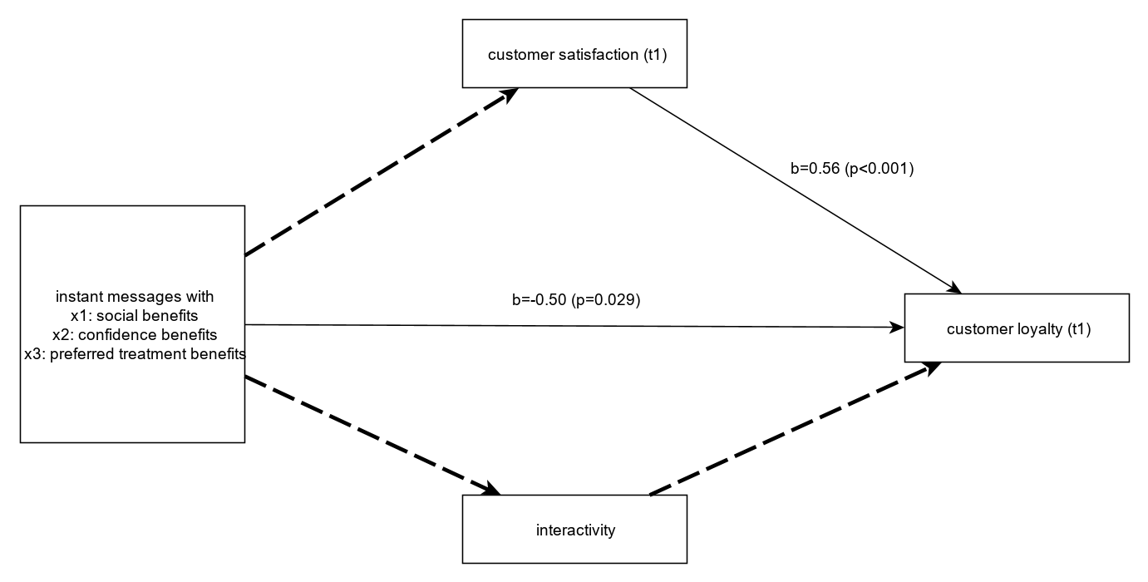
denotes significant relationship
denotes insignificant relationship
Figure 2. Mediation Results

  - Table Style
This is exemplary text with cross reference (see Table 1) to show correct table style. The caption is in “Figure/Table Caption” style and integrated, but above the table.
Table 1. Types of Theories (based on: Markus and Robey 1988)
 | Variance Theory | Process Theory
Role of Time | Static | Longitudinal
Definition | The cause is necessary and sufficient for the outcome | Causations consists of necessary conditions in sequence; chance and random events play a role
Assumptions | Outcome will invariable occur when necessary and sufficient conditions are present | Outcomes may not occur (even when conditions are present)
Elements | Variables | Discrete Outcomes
Logical Form | If X, then Y; if more X, then more Y | If not X, then not Y; cannot be extended to “more X” and “more Y”
  - Another Table
This is exemplary text with cross reference (see Table 2) to show another example of a table. The caption is in “Figure/Table Caption” style and integrated, but below the figure.
Table 2. Initial Factor Loadings
 | Satisfaction | Loyalty | Confidence Benefits | Social Benefits | Preferred treatment Benefits
SAT1 | 0.859 | 0.738 | 0.332 | 0.295 | 0.366
SAT2 | 0.902 | 0.750 | 0.360 | 0.332 | 0.395
SAT3 | 0.903 | 0.694 | 0.232 | 0.201 | 0.271
LOY1 | 0.685 | 0.841 | 0.534 | 0.444 | 0.446
LOY2 | 0.274 | 0.563 | 0.040 | 0.207 | 0.159
LOY3 | 0.828 | 0.861 | 0.319 | 0.314 | 0.344
SB1 | 0.349 | 0.453 | 0.621 | 0.858 | 0.710
SB2 | 0.267 | 0.383 | 0.672 | 0.923 | 0.589
SB3 | 0.277 | 0.369 | 0.678 | 0.889 | 0.616
SB4 | 0.328 | 0.406 | 0.653 | 0.896 | 0.744
SB5 | 0.168 | 0.316 | 0.726 | 0.897 | 0.617
CB1 | 0.254 | 0.308 | 0.877 | 0.569 | 0.610
CB2 | 0.347 | 0.311 | 0.834 | 0.699 | 0.701
CB3 | 0.434 | 0.500 | 0.845 | 0.740 | 0.779
CB4 | 0.104 | 0.258 | 0.768 | 0.474 | 0.551
CB5 | 0.260 | 0.326 | 0.893 | 0.727 | 0.797
PTB1 | 0.251 | 0.202 | 0.469 | 0.437 | 0.716
PTB2 | 0.261 | 0.362 | 0.708 | 0.561 | 0.842
PTB3 | 0.466 | 0.489 | 0.722 | 0.755 | 0.877
PTB4 | 0.229 | 0.306 | 0.653 | 0.568 | 0.834
PTB5 | 0.356 | 0.371 | 0.743 | 0.638 | 0.791

  - References in Text
This section provides examples for citing correctly in the text. Please in general use the citation style of the American Psychological Association (APA), Seventh Edition.
    - Indirect Citation in Text
Syntax
Citation text (Author(s), Year)
Example
Much of the work performed by IS practitioners, and managers in general, deals with design (Boland, 2002) - the purposeful organization of resources to accomplish a goal.
    - Direct Citation in Text
Syntax
“Direct citation text” (Author(s), Year, Page(s))
Example
In the early stages of a discipline or with significant changes in the environment, each new artifact created for that discipline or environment is “an experiment that poses a question to nature” (Newell & Simon, 1976, p. 114).
    - Modified Direct Citation in Text
- Use [...] to omit parts of the cited text that are not crucial for its meaning:
“Much of the work performed by IS practitioners [...] deals with design – the purposeful organization of resources to accomplish a goal.” (Hevner et al. 2004, p. 78)
- Add words in square brackets to achieve seamless transitions between your own ideas and the cited text:
Benbasat and Zmud (1999, p. 5) argue that the relevance of IS research is directly related to its applicability in design, stating that the implications of empirical IS research should be “implementable, […] synthesize an existing body of research, […] [or] stimulate critical thinking” among IS practitioners.
  - Managing References
Use Zotero! (or a similar tool) (see Table 3)
- [zoh-TAIR-oh] is a free, easy-to-use tool to help you collect, organize, cite, and share your sources
- Download Zotero citation style on our website https://www.uni-goettingen.de/de/templates/609290.html
- Zotero can be integrated in Microsoft Word
Table 3. Zotero Links
Topic | Link
Quick Start Guide | https://www.zotero.org/support/quick_start_guide
Complete Beginner Guide (Video) | https://www.youtube.com/watch?v=JG7Uq_JFDzE
Citations and Bibliography in Word (Video) | https://youtu.be/JG7Uq_JFDzE?t=512
Set Zotero to English language | http://forums.zotero.org/discussion/4004/?Focus=17166#Comment_17166
Although it is very convenient, and everything is done for you: Visually check all references before handing in:
- Your Zotero database may be incomplete
- Citation style might not work for all types of references (e.g., magazines)
  - List of References
Basic remarks
- List of references is sorted alphabetically.
- “Et al.” is used in text citations if the cited object has more than two authors; in the bibliography all authors must be listed.
- For authors, last names are given first.
- See References section at the end of the document.
Best practices
- Use Zotero for managing your bibliography and citations
- Be aware that references downloaded from the web may not be correct a priori
- Perform regular bibliography checks

References
Author, A. B., & Author, C. D. (Year). Title of the Paper, Journal 1(1), 1-10. (https://doi.org/XXXXX).
DeLone, W. H., & McLean, E. R. (1992). Information Systems Success: The Quest for the Dependent Variable, Information Systems Research 3(1), 60–95. (https://doi.org/10.1287/isre.3.1.60).
Markus, M. L., & Robey, D. (1988). Information Technology and Organizational Change: Causal Structure in Theory and Research, Management Science 34(5), 583–598. (https://doi.org/10.1287/mnsc.34.5.583).

Abbreviations
<Example, ordered alphabetically> (remove this note!)
CIO Chief Information Officer
XML Extensible Markup Language

Appendix
A 1 Title
Here goes your text. This is exemplary text in “Text” style.
Do not include this or the following appendix in the final submission. Remove it from this document.
A 2 Thesis Submission
Upload your thesis and all data to Stud.IP:
- Your thesis in a “normal” (with name) version (PDF and Word) = 2 files
- Your thesis in an anonymous version (PDF and Word) (please remove both your name and the names of the chairholder and supervisor from this version) = 2 files
- All open data and document files (xls, doc, pdf), including: = 1 ZIP file
  - Export from Zotero resources as Zotero RDF with files
  - In case of qualitative research (e.g., interviews): overview of interview partners, transcripts, audio files, coding files
  - In case of quantitative research (e.g., surveys): questionnaire, prototype code, or data scraping code used for data collection, data collected, cleaning procedures, data analysis scripts and outputs
Use the following syntax when uploading your files:
YY_YYYYSS_XX_Titleofyourpaper_LastName.pdf (name version)
YY_YYYYSS_XX_Titleofyourpaper_anon.pdf (anonymous version)
YY_YYYYSS_XX_Titleofyourpaper_LastName_ESM.zip (Electronic supplementary material)
YY should be replaced by BT in case of Bachelor thesis, MT in case of Master thesis, BS in case of seminar thesis, MS in case of Master seminar,
YYYY should be replaced by the year you are starting your thesis, e.g., 2023
SS should stay in the case you start your thesis in the summer semester, or be replaced by WS if you start your thesis in the winter semester,
XX are the initials of your supervisor,
LastName is your last name (not included in anonymous version), Titleofyourpaper is an abbreviation of your paper (roughly max. 12 characters).
Example
BT_2023SS_LS_Mueller_Evolution of TAM.pdf
BT_2023SS_LS_Evolution of TAM_anonymous.pdf
For bachelor and master theses: Also follow the instructions of your examination office. Usually, you must upload the theses to FlexNow. For the examination office, only upload 1 PDF and necessary appendences (if any, no Zotero file or raw data upload to FlexNow necessary).

Erklärung
Hiermit versichere ich, dass ich die Arbeit selbständig ohne fremde Hilfe und ohne Benutzung anderer als der angegebenen Hilfsmittel angefertigt habe. Die von mir verwendeten Hilfsmittel sind:
[hier alle verwendeten Hilfsmittel auflisten und diese Notiz entfernen!, z.B. Zotero, Excel, DeepL Übersetzer, ChatGPT]
Erklärung zur Nutzung von ChatGPT und vergleichbaren Werkzeugen im Rahmen von Prüfungen: In der hier vorliegenden Arbeit habe ich ChatGPT oder eine andere KI wie folgt genutzt:
[ ] gar nicht
[ ] bei der Ideenfindung
[ ] bei der Erstellung der Gliederung
[ ] zum Erstellen einzelner Passagen, insgesamt im Umfang von …% am gesamten Text
[ ] zur Entwicklung von Software-Quelltexten
[ ] zur Optimierung oder Umstrukturierung von Software-Quelltexten
[ ] zum Korrekturlesen oder Optimieren
[ ] Weiteres, nämlich: …
Ich versichere, alle Nutzungen vollständig angegeben zu haben. Fehlende oder fehlerhafte Angaben werden als Täuschungsversuch gewertet.
Ebenso versichere ich, dass diese Arbeit oder Teile daraus weder von mir selbst noch von anderen als Leistungsnachweise andernorts eingereicht wurden. Alle Stellen, die wörtlich oder sinngemäß aus Veröffentlichungen oder anderen Quellen entnommen sind, sind als solche kenntlich gemacht. Sämtliche Sekundärliteratur und sonstige Quellen sind nachgewiesen und in der Bibliographie aufgeführt. Das Gleiche gilt für graphische Darstellungen und Bilder sowie für alle Internet-Quellen. Ich versichere, dass die schriftliche und elektronische Form der Arbeit übereinstimmen.
Ich bin ferner damit einverstanden, dass meine Arbeit zum Zwecke eines Plagiatsabgleichs in elektronischer Form anonymisiert versendet und gespeichert werden kann. Mir ist bekannt, dass von der Korrektur der Arbeit abgesehen werden kann, wenn diese Erklärung nicht erteilt wird.

Göttingen, September 6, 2023

Last Name:
First Name:
Student ID:
Signature: ________________

