Title
[Guidelines for writing theses and papers]

XX weeks (length of time it took to complete) thesis as part of the
(state your full degree) degree at the University of Göttingen/ Seminar paper on…

Submitted on: (Date of submission)  By: (First and last name)  From: (Place of birth)  Matriculation Number: | Supervisor 1: XY  Supervisor 2: XZ

Table of contents
List of abbreviations iv
List of figures v
List of tables vi
1 Structure and length of academic papers 1
1.1 Introduction 1
1.2 Basics (groundwork and definitions) 2
1.3 Main part 2
1.4 Conclusion 3
1.5 References 3
1.6 Appendix 3
1.7 Handout (only if explicitly asked for) 3
2 Formal requirements 4
2.1 Text 4
2.2 Headers and footnotes 4
2.3 Figures and tables 5
2.4 Equations 8
2.5 Subchapters, paragraphs and page margins 8
3 Citation and literature 9
3.1 MISQ-References Format 9
3.2 Types of citations 11
3.2.1 Literal citations 11
3.2.2 Analogous citations 11
3.3 Quality of the literature 12
3.4 Additional formatting opportunities 12
3.5 Citation software 12
4 Submission 13
4.1 General information 13
4.2 Indication of co-authored parts 13
5 References 14
Appendix 15
Certification 16

Exemplary detail:
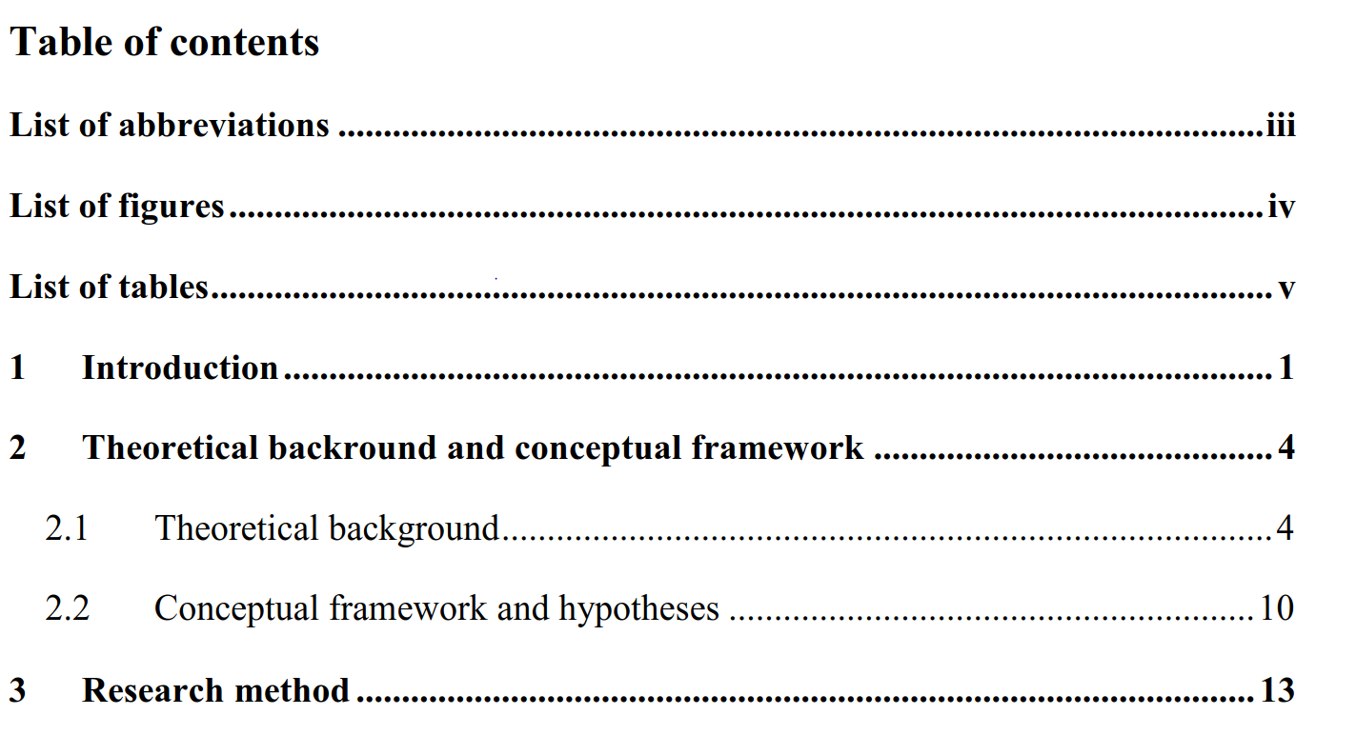

Further information:
- The thesis should be well-founded and structured. A new sub-chapter should only be added if there are at least two subsections.
- The subject of the paper must not be completely processed in just one chapter.
- If different aspects are covered in one chapter or subsection, use paragraphs to structure the text.
- A good structure normally consists four to seven chapters (plus subsections/ subchapters).

List of abbreviations
MISQ = MIS Quarterly
ISR = Information Systems Research

Exemplary list of abbreviations:
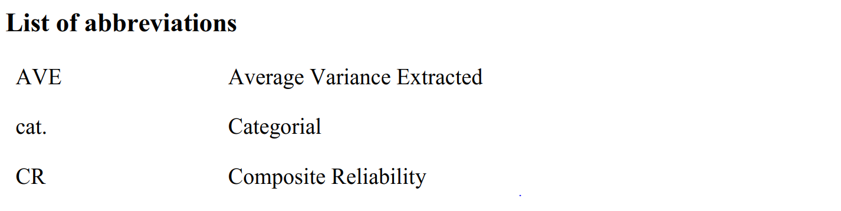

Further information:
The list of abbreviations should be placed after the list of contents and should use continuous Roman numerals (IV) instead of Arabic numbers (4) for page numbers.
All abbreviations used in the work (also from diagrams and overviews) and their meaning in alphabetical order, even if they have already been explained in the text, must be listed in the list of abbreviations. Abbreviations in accordance with the current edition of the “Duden”, abbreviations customary in business, as well as generally used abbreviations for journals, newspapers, institutions and organizations are permissible.
For example:
- IT = Information technology
- ITIL = IT Infrastructure Library
- CobiT = Control Objectives for Information and Related Technology
Abbreviations that are not commonly used are not permitted, as they disturb the reading flow (e.g., AS for application system). Use abbreviations sparsely; some are common and should not be included in the list of abbreviations (e.g., etc., viz., e.g., …)

List of figures
Figure 1. Transactional model of stress [Galluch et al. 2015, p. 3; Lazarus & Folkman 1984, p. 19; Ragu-Nathan et al. 2008, p. 419] 7

Exemplary list of figures:
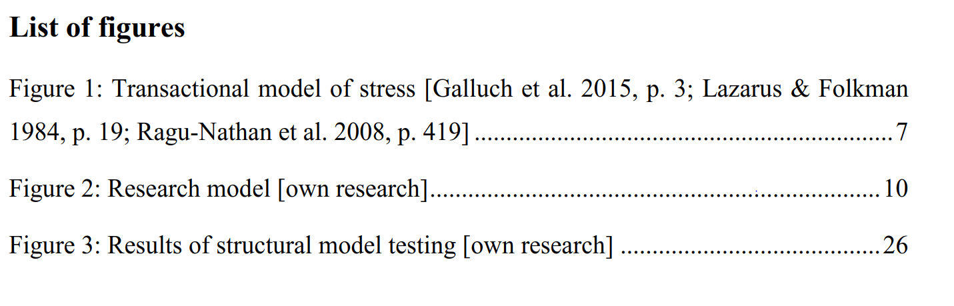

Further information:
- If there are more than four figures, statistics, tables, etc. used in the text, a list of figures and tables should be included in the thesis/paper. In this list, the figures should be presented, named, and numbered on a separate page after the list of abbreviations.
- All forms of display can be called figures and presented in one list of figures. A finer subdivision is sometimes not necessary.

List of tables
Table 1. Overview of XY [own research] 7

Exemplary detail:
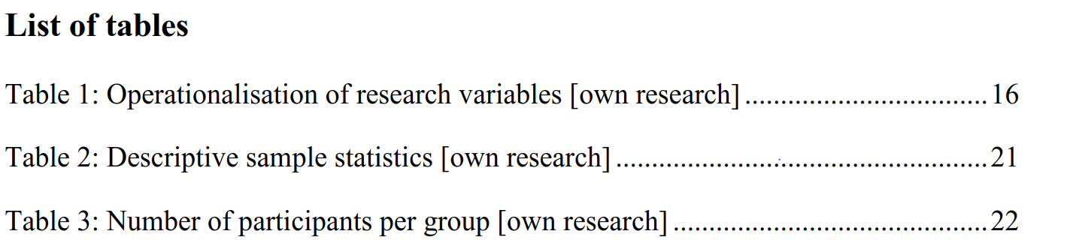

Further information:
- If there are more than four figures, statistics, tables etc. used in the text, a list of figures and tables should be included in the thesis/paper. In this list, the tables/statistics should be presented, named, and numbered on a separate page after the list of abbreviations.
- Every table must be named and listed in the list of tables.

Structure and length of academic papers
A thesis or paper normally consists the following parts:
- Cover page
- Table of contents
- List of abbreviations (if necessary)
- List of figures (if necessary)
- List of symbols (if necessary)
- Content
- References
- Other sources (if necessary)
- Appendix (if necessary)
- Handout
The text of the thesis/paper follows the list of figures/ tables. It should be written in proper English orthography (British or American). In general, it consists of the presentation of the problem, a section of definitions, the actual processing of the problem (and possibly a solution), and a summary of the main findings. A possible, typical structure could be:
- Introduction
- Groundwork/literature review
- Methods/analysis
- Findings/evaluation
- Conclusion
The length of a seminar paper is indicated in the description of said seminar or must be individually set with the supervisor. A bachelor thesis has a length of circa 30 pages. A master thesis has a length of circa 60 pages. In any case, the length refers to the number of pages with main content, thus EXCLUDING tables and figures.

Introduction
- In the first section you should always present the given issue of the paper/thesis. Further comments regarding the relevance of the issue are also applicable.
- You should specify some aspects of the problem as well as central issues that have to be solved in the paper.
- The following should be stated in the introduction: a short overview of the procedure, how, and in which sequence the issues are going to be covered.
- The following structure can be used for the introduction (maximum length of up to 3 pages, depending on the overall length of the paper):
- Introduction of the topic
- Formulation of the issue
- Definition of the subject (including subjects that belong to the topic, but are not covered)
- Structure of the paper/thesis (reasons and motivation for the chosen structure)

Basics (groundwork and definitions)
- In the second part, central terms and concepts need to be defined and classified.
- It is not a matter of looking for definitions from lexicons, but of using problem-oriented definitions.
- Often, some terms can be defined differently. So, a discussion of different approaches can be useful, before you choose a binding definition for the paper/thesis.
- A short literature review is useful especially for practical papers/theses (e.g. according to Webster and Watson). The reader should be informed of the quantity and type of research papers published, related to the given issue.

Main section
- In the main section of the paper/ thesis (which should be not named “main part” obviously), the actual issue or problem should be dealt with.
- In doing so, a theoretical model can be pictured, or theory-driven hypotheses can be developed, which are then examined empirically in a subsequent analysis.
- In this part, it is essential to not just use and collect textbook knowledge but handle the issue in a reflective and goal-orientated manner.
- For a thesis: if some parts of the thesis are co-authored by another student (e.g., a survey) this needs to be clarified (see chapter 4.2).

Conclusion
- The solution of the issues and problems dealt with should be represented briefly and concisely.
- In addition, you can give a further overview of issues that should be covered in future research.
- A critical reflection of the author’s work is always reasonable at this point.

References
- A bibliography must be attached to the work.
- The bibliography or list of references lists all publications cited in the paper/thesis, including those in tables or figures.
- Literature that was read but not cited does not belong in the list of references.

Appendix
You can put figures and diagrams in the appendix, which provide additional information. An appendix is not a necessary part of a paper/thesis, but rather an optional element, if further explanations are essential. This part should not be extended needlessly.

Handout (only if explicitly asked for)
- The handout (1-4 pages) should make it easier for seminar participants to understand the content of your presentation. Speak to your supervisor in order to find out if a handout is necessary.
- A handout contains the topic, the editor, the structure, central definitions if necessary, tables, illustrations, theses, and formulas.

Formal requirements
In this section, the formal requirements for bachelor and master thesis as well as for seminar papers will be explained.

Text
- The body of your work can be formatted in Arial, Calibri, or Times New Roman. The font size must be 12 pt. (Arial 11 pt.)
- Please use a line-spacing of 1.5 lines.
- Please format the text body as a fully justified text.

Headers and footnotes
Headers
Exemplary detail:
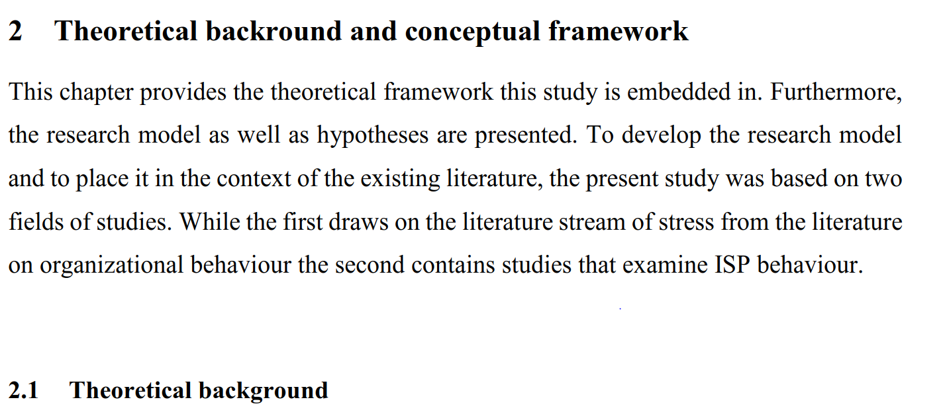
Further information:
- Headers on the first level can be formatted in 14 pt. and bold, and all sub-levels must be formatted in the size of the text and bold, meaning 12pt. or 11pt. (see this document as an example).
- Avoid two or more subsequent headers without a text interposed (this applies also for e.g., chapter 2 and chapter 2.1, see example)
- A new subchapter should only be added if there are at least two subsections (e.g., don’t add chapter 2.1 if there is no chapter 2.2)
- It is advisable to inform the reader about the structure of the following sections (see example).
Footnotes
- Footnotes should be used carefully.
- If a reference is important, then it belongs in the text. If the reference is not necessary, you should consider whether the reference can be omitted.
- You can use footnotes if certain sections need further explanations, but they could disturb the reading flow.
- Footnotes should be written as normal sentences. They begin with a capital letter and end with a period.
- They should be numbered consecutively in Arabic numerals.
- Footnotes should be formatted in font size 10 pt.
- Concerning footnotes and punctuation: If a footnote relates to the whole sentence, it should be placed behind the punctuation mark, if the footnote relates to just one word, it should be placed behind the word it relates to and before the punctuation mark.

Figures and tables
- In figures and tables, you can summarize the pictured facts, illustrate certain matters, or highlight statements.
- Figures and tables support your argumentation but cannot replace your explanations. So further comments are necessary.
- If figures or tables include necessary information, put them in the text. If they provide only additional information, they belong in the appendix.
- Figures, tables, etc. must be numbered and labelled continuously (Arial, font size 11 pt.), For example, Figure 1. Trade agreements between Canada and USA (the exact format according to MISQ-style can be seen in the example below)
- If you refer to a figure/table in the text, for example “As seen in Figure 1, the effect of…”, the word “Figure” has the same notation as in the label (with a capital first letter).
- Figures and tables taken from other sources need to be cited correctly. The label must include the source of the figure or table, for example Figure 1: Trade Agreements USA/ GER [source: XX].
- If you created the figure or table, just write “own research”.
- If figures from different sources are processed, recomposed and/or made comparable by rearrangement, so that it is no longer possible to identify the source of each individual figure, all sources must be indicated at the beginning of the section. A footnote should indicate the nature of the processing.
Labelling and format of a figure according to MISQ-style
Please place a table around the figure to create clear borders. The label must be put in the table row below the figure. This row must be filled with black and the labeling text must be formatted in white color. Please note, that you must use Arial as a font (11 pt.) in your figures and their label, regardless of the font you chose for your general text!
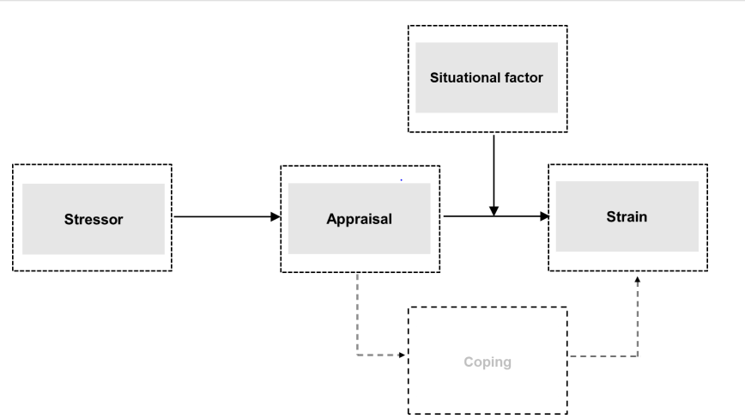
Figure 1. Transactional model of stress [source: Galluch et al. 2015, p. 3; Lazarus & Folkman 1984, p. 19; Ragu-Nathan et al. 2008, p. 419]

Labelling and format of a table according to MISQ-style
Please label your table in an additional row above your first content-related row of the table. This row must be filled with black and the labeling text must be formatted in white color. Please note that you must use Arial as a font (11 pt.) in your tables and their label, regardless of the font you chose for your general text!

Table 1. Overview of XY [own research]
Header 1 | Header 2
… | …

Further information:
Remember to explain or at least refer to every figure or table in the text. Watch out for correct notation (with a capital F/ T, for example “As seen in Figure 1, the effect of…”).

Equations
$$\left[\frac{\left(Z-E\left(Z\right)\right)}{V^{-1}\left(Z-E\left(Z\right)\right)}\right]=\frac{2\left(\frac{∂y}{∂x}\right)}{V^{-1}(Z-E\left(Z\right))}$$ | (1)
This is how formulas or equations should be presented, like equation (1) above. Formula symbols and the meaning of abbreviations need to be explained. If you created any formulas, they need to be defined. A list of formula symbols can be necessary (after the list of tables).

Subchapters, paragraphs and page margins
Sublevels
Do not use more than four subchapters (sublevels). Create only a new sublevel if it is necessary.
Paragraphs and page margins
- Use a line spacing of 1.5. Paragraphs should be reasonably placed and in relation to their content.
- The page margins should be 2.5 cm for all margins.
- The text should be fully justified.

Citation and literature
Every time external information or a foreign idea is taken as a source for an academic paper, whether it is used literally or analogous, it must be cited correctly.
An essential requirement for academic work is the correct and complete citation of foreign ideas.
Correct and complete citation means, that every foreign idea must be marked, in the text and in the references. A consistent reference format and citation style are especially important. There must be no differences in the notation and sources cited, in the references and in the text. Use the MISQ-References Format (http://misq.org/manuscript-guidelines).

MISQ-References Format
Use the MISQ-Style for your paper or thesis, as explained in the following:
Sequence: Entries should be ordered alphabetically (in text and Reference section) according to authors’ or editors’ last names, or the title of the work for items with no author or editor listed.
References in text (see Chapter 3.2): References in text should be of the following format: (Jones et al. 1995; Smith 1996).
An example for a correct citation in the text:
Others have argued that because services are performed for particular clients in a particular circumstance, service innovation should be examined as emergent, interactive, and dynamic, as well as knowledge and information intensive as communication flows between providers and customers (Miles 2008, p. 117).
Use of et al.: In the text body, the use of “et al.” is permittable. You may not use “et al.” in the list of References. There, the names of all authors and editors must be listed. If you are using End Notes, please check your references to ensure that the settings are correct and that all authors are listed in the references.
Use of ibid.: Authors may not use “ibid.” to indicate the consecutive citation of a specific passage from one author. Literal and analogous citation should be marked completely (as seen above).

Different types of references should include the following in the list of references (bibliography):
- References to items in periodicals: Author(s) (last names are given first, even for multiple instances), year, title, journal, volume, number, month, pages.
Exemplary detail:
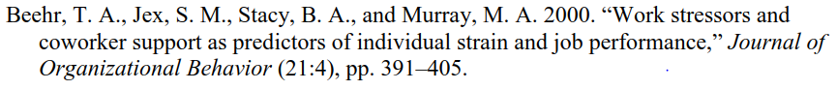

- References to reports or proceedings: Author’s name and title of report (same style as above), report number, source, editor and/or publisher as appropriate, city and state/country of publisher OR full name of conference as appropriate, including date and pages.
Exemplary detail:
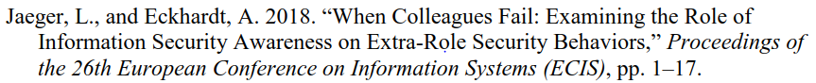

- References to books: Author’s name (same style as above), year, title, city, state/country, publisher, page, or chapter.
Exemplary detail:
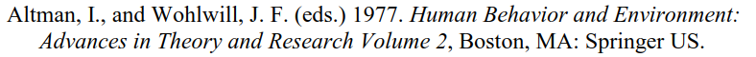

- References to internet pages: Author’s name, title, medium, date, edition, page, etc. (if possible), Link with date of call.
Exemplary detail:
An example of a correct bibliography (list of references) can be found at the end of this template.
Moreover, it is helpful to read an MISQ-Article if there are further open questions, and to check how to cite correctly and how to create a bibliography.

Types of citations
Concerning the type of citation, one can distinguish between literal and analogous citations.

Literal citations
Text passages adopted literally (sentences, clause, individual words) must be cited with quotations marks. If you cite literally, alterations of the text passages are not allowed. The omission of one word must be mark with two dots, the omission of two or more words must be marked with three dots. Long literal citations should be avoided because, it is better to write a corresponding summary instead. It is necessary to cite literally in the following four cases:
- It is not possible to explain the relevant content in a better or shorter manner.
- It is a concept formation.
- If textual criticism or critical comments have to be formulated, namely if you have to interpret or criticize the author.
- Literature in other languages than English as addition to the analogous reproduction, so that the reader can check if the author translated correctly.
If something is added within the citation, it must be marked correctly. The added passage needs to be presented in brackets and initials of the author must be added. For example: “The function of … (the network, the author) … can be summarized …”.

Analogous citations
It is important to watch out for a complete citation of used references for analogous citations as well.
If nothing else is indicated, the citation refers only to the marked sentence. If various sentences are cited analogously, you must indicate it in a proper manner (e.g., through indentation or an indication of the extent of the analogous citation). If such an indication is missing, it will be assumed that only the marked sentence is cited.
If you write a text passage based on multiple pages of an external source, it must be clearly stated that your explanations are based on the thoughts of author XY. The citation must indicate the exact pages of the adopted thoughts, such as (Jones 2012, pp. 12-16).
A citation should always come from its primary source and not from a secondary source. If a citation from a secondary source is necessary (because e.g., a primary source could not be found), you should first mention the primary source, and then add a footnote “cited from [secondary source]”.
When there are multiple authors who explain the same content, all of them should be named. If their number exceeds for, you can exemplary select four of them and indicate them as follows: (see e.g., author 1, author 2, author 3, author 4).
Wrong or missing indication of used sources generally leads to a rejection of the thesis/ paper.

Quality of the literature
References and literature sources are often of different quality. Practice-orientated sources enrich academic papers but should not be used solely. It is expected, that English (or German) sources will be sighted and used exclusively. Wikipedia and comparable lexicons are not appropriate!

Additional formatting opportunities
In order to improve readability, one could format the title, the name of the periodical, or report in italics.

Citation software
The use of citation- and reference management programs liken Citavi or Mendeley is recommend.
The University of Göttingen offers a campus license for Citavi for students and employees of the university. Students and employees can download the full version for free on up to two devices. Mendeley is free of cost.

Submission

General information
- You must submit a PDF file via E-mail to your supervisor.
- For Bachelor and Master Theses, please inform yourself at the examination office (Prüfungsamt) about current submission regulations.
- For seminar papers, a printed version may be required by your supervisory. It should be submitted to your supervisor or the secretary’s office. Coordinate with your supervisor! If a printed version is needed, please print it single-sided.
- Original Files (Word, etc.) must be submitted on request.
- Sources must be kept up until grading.

Indication of co-authored parts
Specifically, in thesis projects, it can be necessary to co-author parts of the text with other students, such as in the creation of a survey. This should be indicated in the certification, including a specification which parts are co-authored.
If whole passages of the text are identical, this needs to be also indicated in the header of the respective chapter. It is sufficient to list the names of all authors in squared brackets.
In seminar papers (especially group projects) these indications (in both the header and the certification) are not necessary, as a joint handling of the paper is generally assumed.

References
Ackoff, R. L. 1961. “Management Misinformation Systems,” Management Science (14:4), S. 147-156.
Bonini, C. P. 1963. Simulation of Information and Decision Systems in the Firm, Englewood Cliffs, NJ: Prentice-Hall.
Chenhall, R. H., and Romano, C. A. 1989. “Formal Planning and Control Presence and Impact on the Growth of Small Manufacturing Firms,” in Job Generation by the Small Business Sector in Australia, W. C. Dunlop and A. J. Williams (eds.), Newcastle: Institute of Industrial Economics, S. 71-89.
Mair, S. Staatsversagen und Staatszerfall, in: Informationen zur Politischen Bildung (2009), Nr. 303, S. 8-10. http://www.bpb.de/files/ES3BIB.pdf. Accessed: 01.10.2009.

Appendix
As described in chapter 1.5, you can add appendices here. Use an alphabetic numeration.

Certification
I hereby declare that I wrote this thesis paper independently, without assistance from external parties, and without use of other resources than those indicated. All information taken from other publications or sources in text or in meaning are duly acknowledged in the text. The written and electronic forms of the thesis paper are the same. I give my consent to have this thesis checked by plagiarism software.

Place, Date |  | Signature

