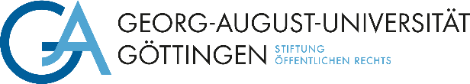

The Department at the Georg-August-Universität Göttingen is looking to fill the position of

**Administrative Assistant (f/m/d)**

**- Pay grade** **TV-L -**

This administrative position should be filled by Date. The regular working hours will be (currently       hours per week) with a limited contract of       year(s) / to      .

**Your duties**

• Managing budgetary and third-party funds

• Purchasing office, business supplies, books, etc.

• Event organizing and tending to international guests

• Website care

• Preparing and organizing business trips

• Coordinating schedules

• Involvement in organising and preparing lectures and courses and supervising students

• Running the office

**Job profile**

• Successful applicants will have completed a vocational training degree as an administrative specialist or have passed Administrative Course I or an equivalent administrative clerk examination and have many years of professional experience

• Proficiency in using Microsoft Office applications (Word, Outlook, Excel, PowerPoint)

• Working knowledge of the LANGUAGE language

• Experience with the SAP module MODULE NAME is desirable

• Secretarial experience is also a plus

The University of Göttingen is an equal opportunities employer and places particular emphasis on fostering career opportunities for women. Qualified women are therefore strongly encouraged to apply in fields in which they are underrepresented. The university has committed itself to being a family-friendly institution and supports their employees in balancing work and family life.The mission of the University is to employ a greater number of severely disabled persons. Applications from severely disabled persons with equivalent qualifications will be given preference.

Please send your application with the usual documents by Date/within **three weeks after publication of this advert** to



**Georg-August-Universität Göttingen**,

**Department,****StreetHouseNr,** **PLZ Göttingen,**

**e-mail:** **.**

If you have any questions, please contact

Ms./Mr. Name, phone:      , e-mail:      .

**Please note:**

With submission of your application, you accept the processing of your applicant data in terms of data-protection law. Further information on the legal basis and data usage is provided in the Hinweisblatt zur Datenschutzgrundverordnung (DSGVO) <https://www.uni-goettingen.de/hinweisdsgvo>